CS 255 Project Two: System Design Document
DriverPass System
Chandra Newsome-Simmons
Southern New Hampshire University
CS 255: Systems Analysis and Design
October 18, 2026

UML Diagrams

UML Use Case Diagram

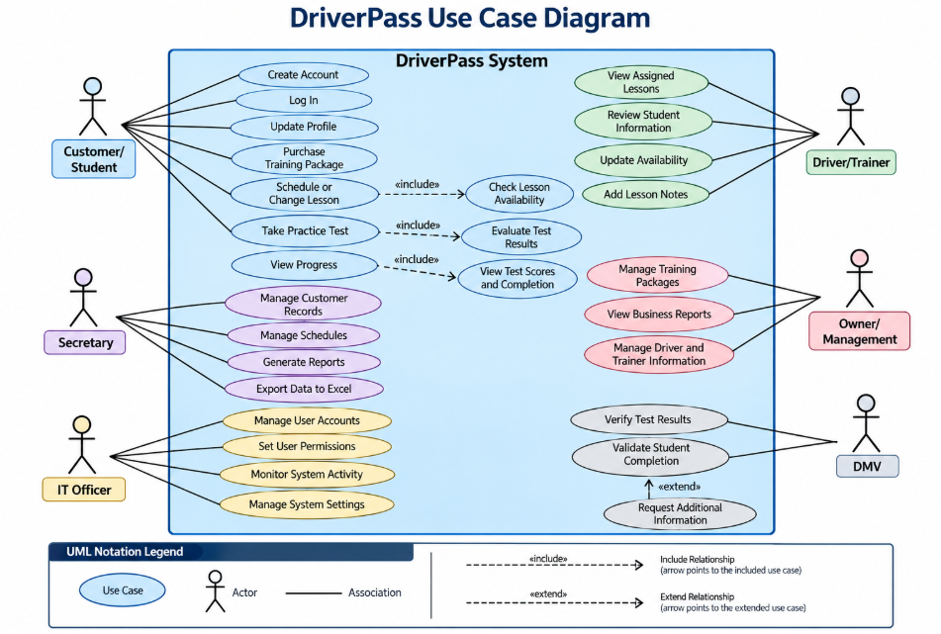

UML Activity Diagrams

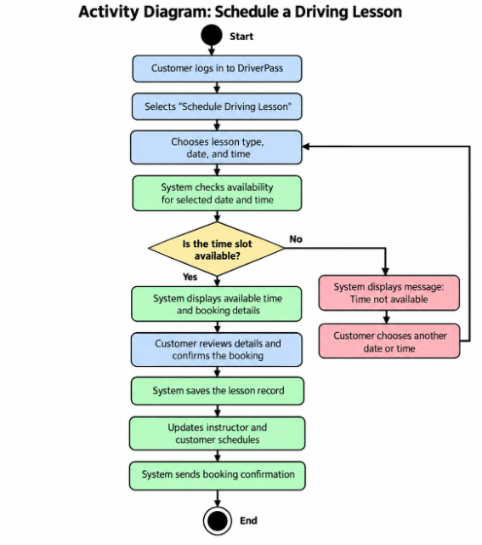

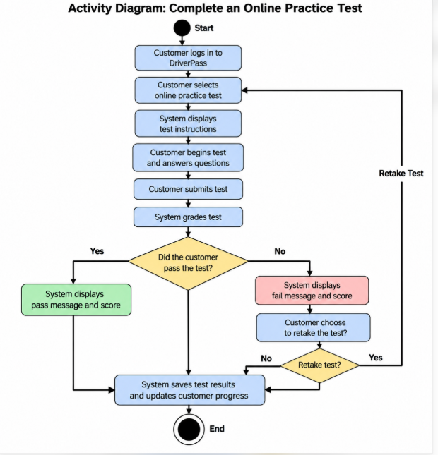

UML Sequence Diagram

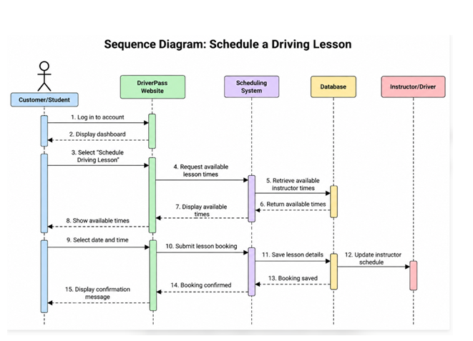

UML Class Diagram

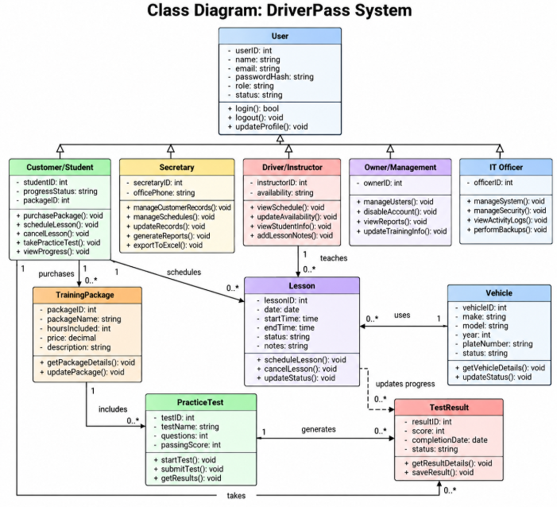

Technical Requirements

The DriverPass system will require reliable hardware, software, development tools, and network infrastructure to support its online driver training services. Based on the system diagrams, the application must allow customers to create accounts, purchase training packages, schedule or cancel driving lessons, take online practice tests, and review their progress. Employees must also be able to manage customer records, lesson schedules, driver and trainer information, and business reports. The following technical requirements describe the resources needed to support these functions.

Hardware Requirements
DriverPass will need a reliable server environment to host its website, application, and database. A cloud-based hosting environment is recommended because it supports remote access and can be expanded as the business grows. Customers and employees will need computers, tablets, or smartphones with internet access to use the system. Employees who manage schedules, customer information, and reports should have computers capable of running a modern web browser. Reliable network connectivity and routine data backups will also be necessary to maintain service availability and protect business information.

Software Requirements
The system will require a web application that customers and employees can access through a modern web browser. A database management system will store customer account information, purchased training packages, driving lesson schedules, instructor and vehicle assignments, practice test results, and student progress. The application must provide secure login and role-based access so that users can access only the functions and information appropriate to their responsibilities.
The software must support online practice tests and training materials, lesson scheduling and cancellation, progress tracking, and administrative record management. It should also generate reports and export selected records to Microsoft Excel-compatible files. Authorized management personnel must be able to manage training packages and driver or trainer information, while the IT officer must be able to manage system access. The system should also allow the owner to disable access when necessary.

Development Tools and Technologies
Lucidchart will be used to create the UML use case, activity, sequence, and class diagrams that describe the system design. Developers will need a suitable programming environment, source-code management tools, and software testing tools to build, review, and maintain the application. Database design and administration tools will also be needed to organize and maintain stored information.
Testing must verify that account management, lesson scheduling, practice tests, progress tracking, reporting, and user permissions function correctly. The system should be tested before release to identify errors, prevent scheduling conflicts, and confirm that information is saved and displayed accurately.

Network and Infrastructure Requirements
Because DriverPass provides online services, the system will require a stable internet connection and secure communication between users' devices and the application. The website should use HTTPS to protect information transmitted between users and the server. Cloud hosting, system monitoring, regular backups, and recovery procedures will help maintain availability and reduce the risk of data loss.
The system should allow authorized users to view previously stored information when an internet connection is unavailable. However, users must be connected to the internet to create or modify records, including customer information and lesson schedules. This approach supports limited offline access while helping maintain accurate and consistent information in the central database.

Security and Maintenance Requirements
DriverPass must protect customer information, account credentials, training records, lesson schedules, and business reports. The system should use secure authentication, role-based permissions, encrypted data transmission, appropriate protection for stored information, and activity logs to record important actions. Access to administrative functions, reports, exports, and sensitive records must be restricted to authorized users.
Regular software updates, security testing, database backups, and system monitoring will be necessary to maintain reliability. The application should also be tested for accuracy, performance, usability, and compatibility with commonly used devices and browsers. These requirements will help DriverPass provide dependable online training services while protecting customer information and supporting daily business operations.

